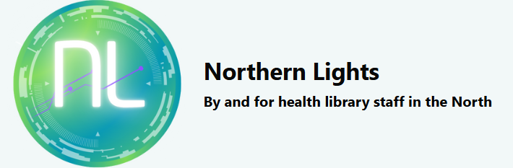
Northern Lights Editors Guide
Contents
Northern Lights Editors Guide 1
Adding/ scheduling a new post 2
Adding the post contents 2
Adding an image to a blog post 4
Adding Tags 4
Adding Guest Author Details 6
Previewing the post 7
Saving and publishing 7
Updating the Home page with the new Post 8
Promoting new content 10

Adding/ scheduling a new post
Log into the Northern Lights WordPress administrator dashboard:
https://northernlightsblog.net/wp-admin/index.php
Log in using the bottom option "log in with username and password"

Click on Posts on the left-hand side. Click Add Post.

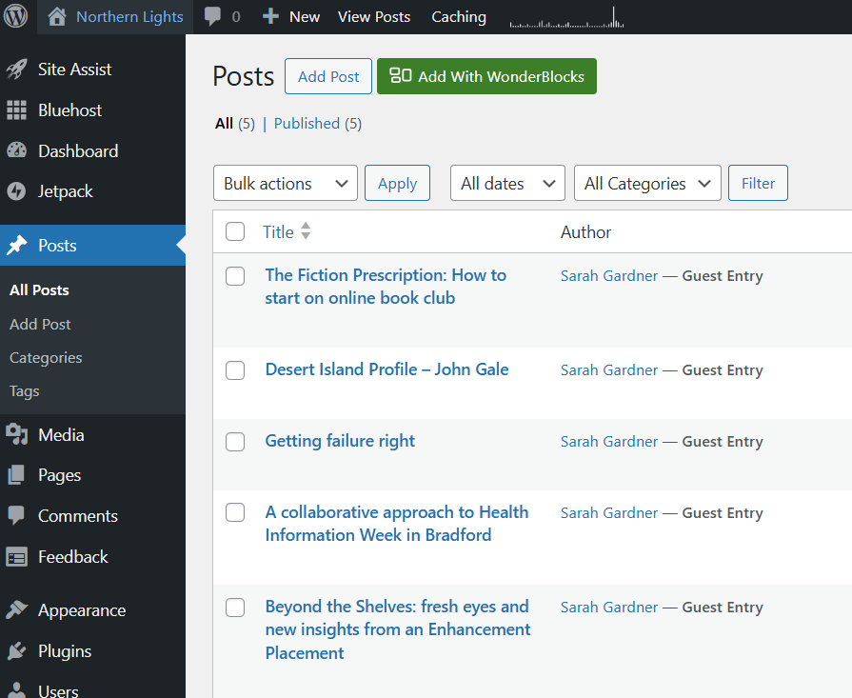

Adding the post contents
Populate the Add title box and copy and paste the blog content in the Type/ to choose a block space
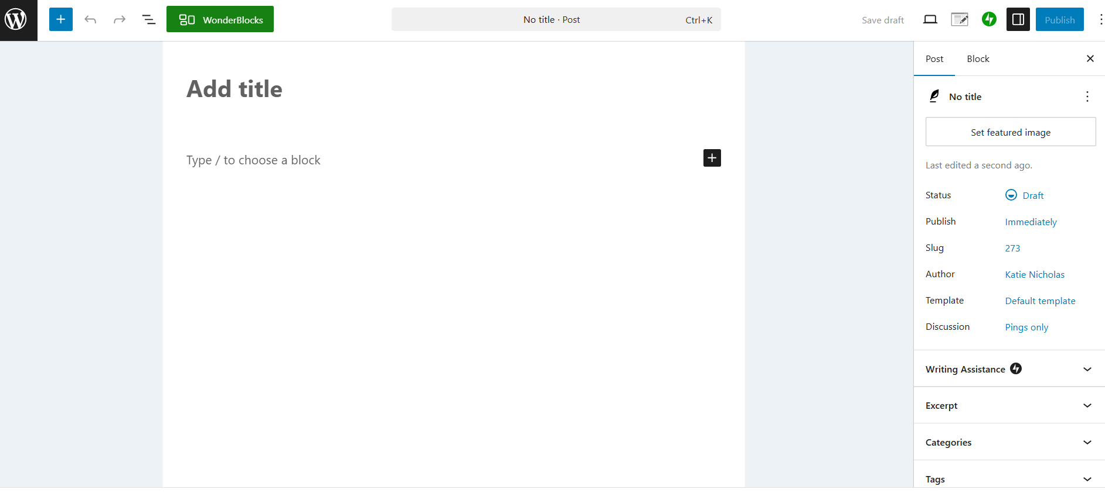
To add a Heading to the content (this is preferable to just using bold type for accessibility purposes) click on the text you want to make a Heading then click the paragraph symbol and click "Heading"
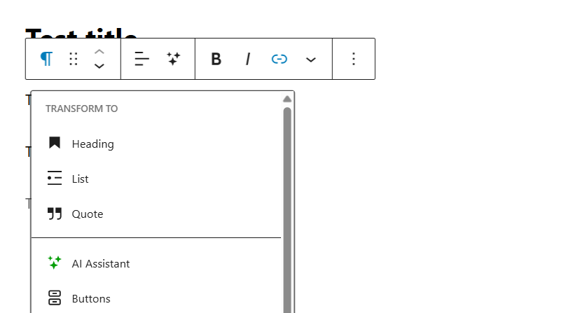

You can also use the plus symbol to add different types of content block e.g. an image, picture gallery or quote. Don't forget to add the Author name and Organisation details at the bottom of the post.
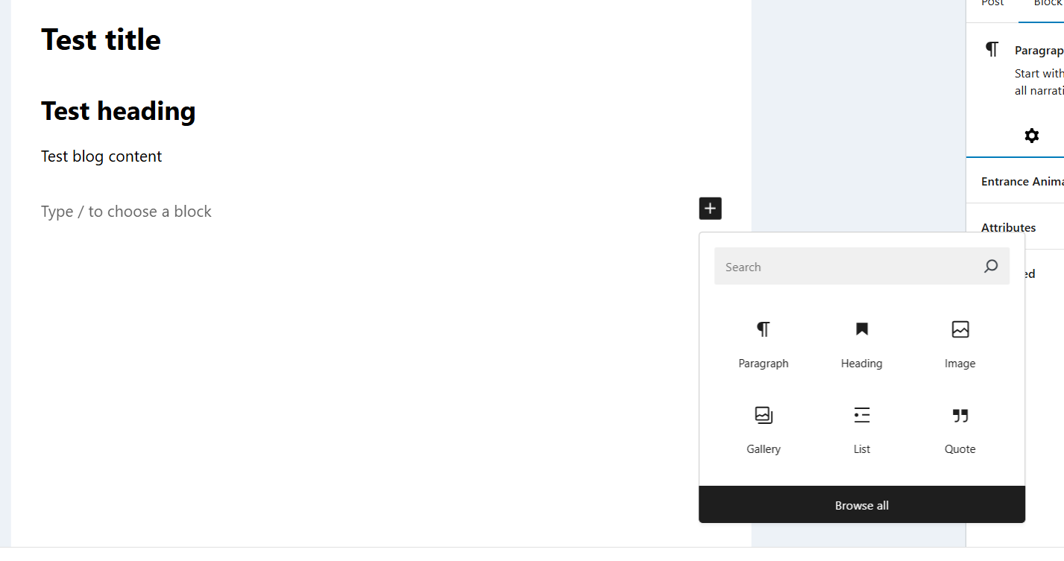

Adding an image to a blog post
You can upload an image file that you've already saved, select an image from the library on the site, or generate an image (apply caution with generated images).

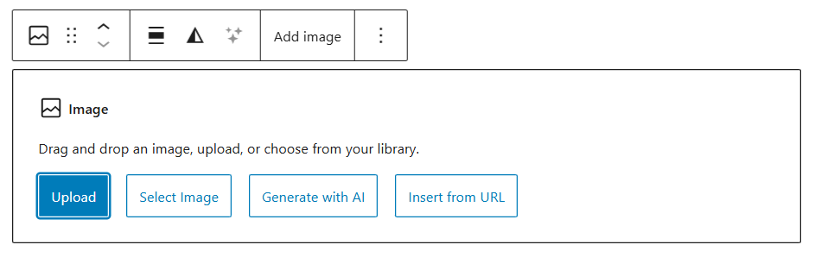
Once you've uploaded an image a box will appear on the right hand-side. From here you can edit the image size and add Alt text. Alt text is really important for accessibility so don’t forget to add a description of the image there. You can read more about How to write good Alt text here
Once you're happy click on the space outside the post to get back to the post content.

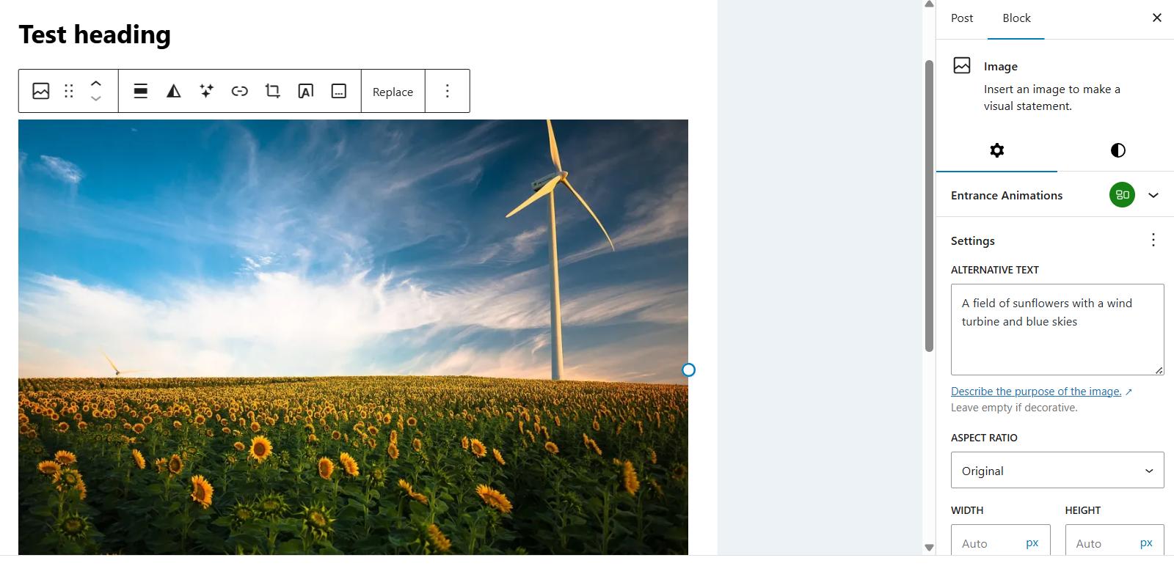

Adding Tags
On the right-hand side click on the arrow that says Tags. Select from the Northern Lights NEW tag list to add the relevant tag(s). Use the format on the spreadsheet to add a tag e.g. capitalise each word. Adding tags not on the spreadsheet should be an exception. If you add a brand-new tag that is not on the existing site or spreadsheet, remember it will need adding to the tag spreadsheet and committee will need to agree on a definition.

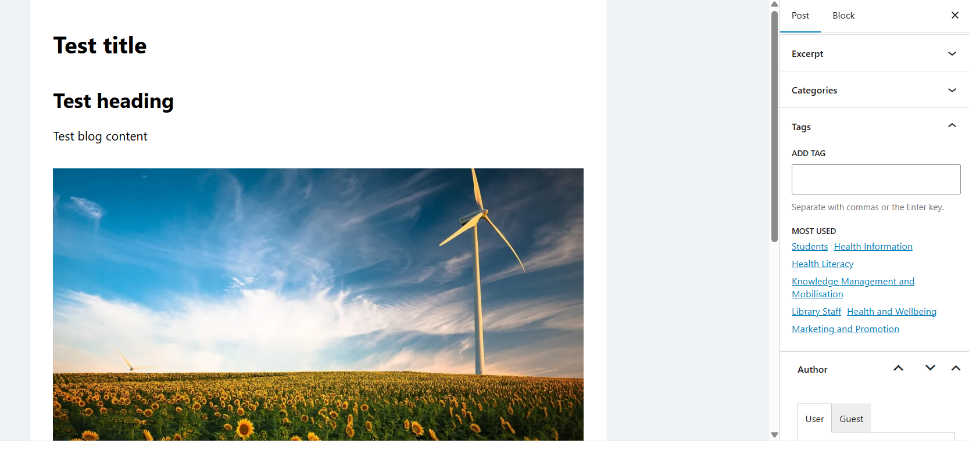
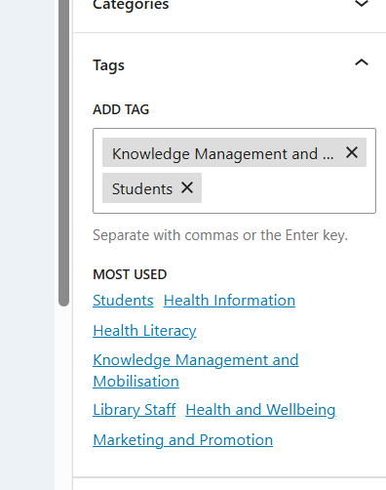

New tags will also need the definition from the spreadsheet adding to Tags page. Click on Posts and click on Tags. Hover over the Tag to Edit and add Descriptions for Tags. Definitions are available in the spreadsheet.
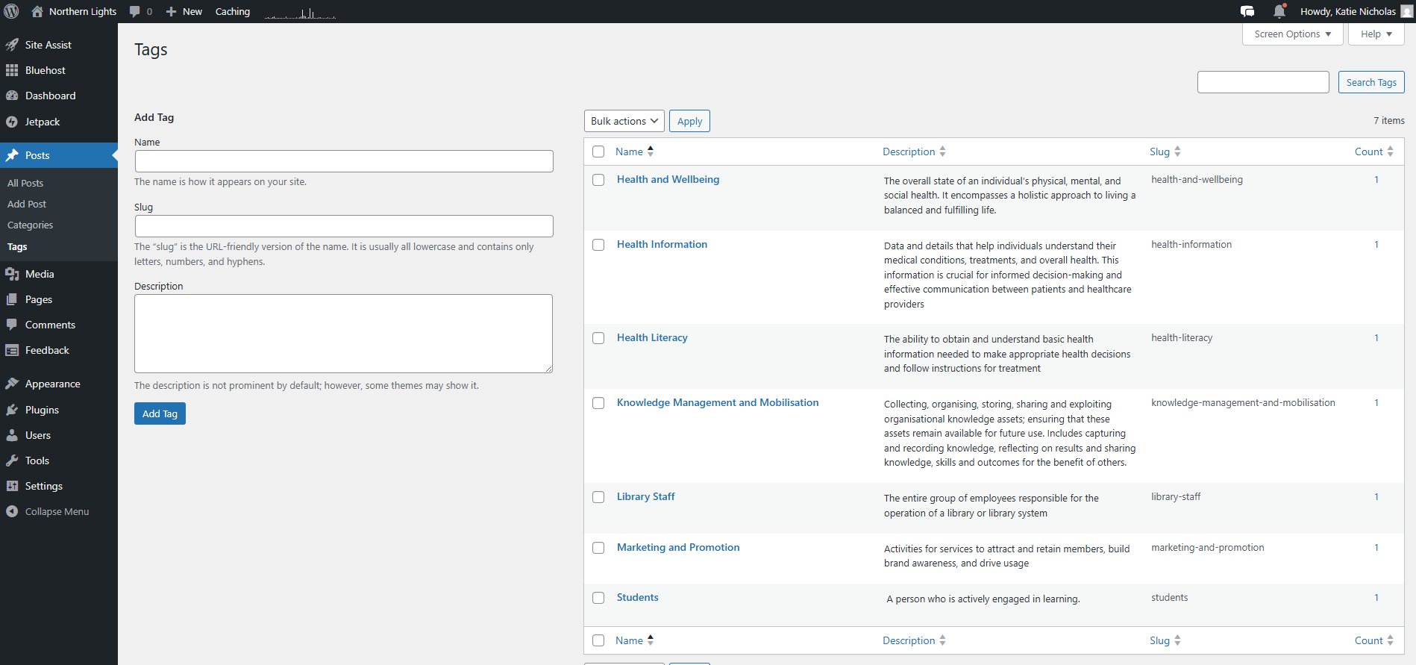

Adding Guest Author Details
So that every author on the site isn't the person who has added the post, rather than the actual author, you need add a Guest Author to a post. On the right-hand side click on the Author drop-down. It will default to "User". Click on the "Guest" tab and write in the name of the post author.
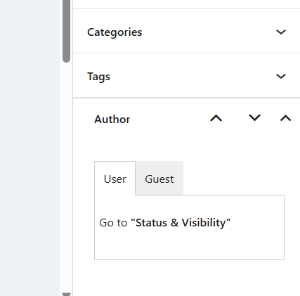
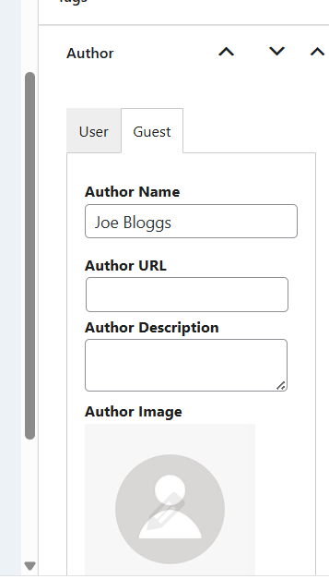

Previewing the post
To check you're happy with the way the page will look upon publication click the View icon in the top right (the little button laptop window) and click "Preview in a new tab"
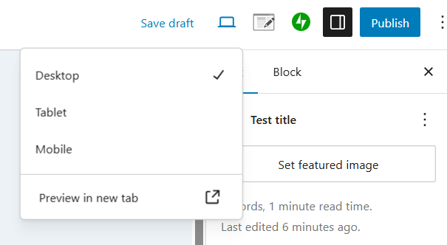

Saving and publishing
Once you're happy with the post you can either save it as a draft and revisit later or publish it. Click the "Save draft" button in the top right to save the post and come back to it later. If you're ready to Publish you can click the "Publish" button in the top right.
If you want to schedule a post to be published later, click on "immediately" on the right-hand side and select the date and time of publication.

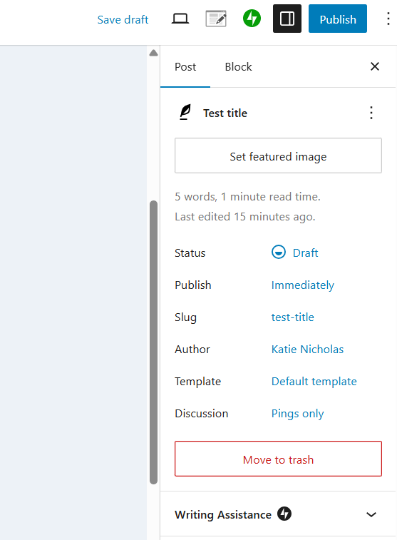

To return to the Dashboard at any time click on the W symbol in the top left corner. Once saved or published you will see the post listed in the "Posts" list by clicking on the "Posts" button on the left-hand side of the dashboard. Obviously, my example still says Draft as I didn’t want to actually publish it! Hovering over the post title reveals more buttons. The Preview/ View option will open the post URL – you'll need this for the next step. Under Author it will show the person who added the post and add that it's a Guest Entry, this is where the name of the actual post author has been added.

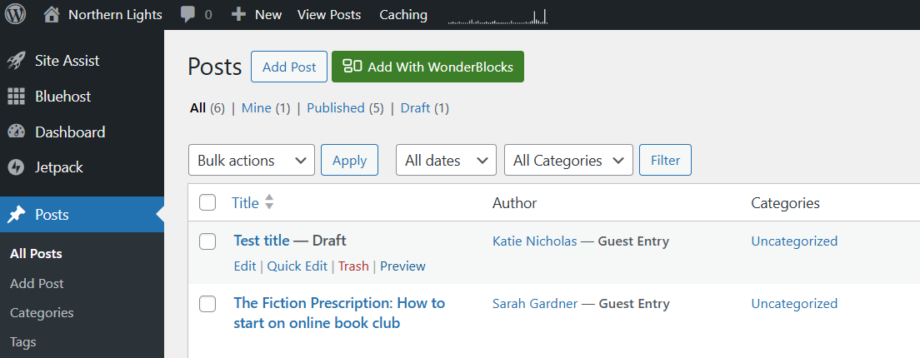

Updating the Home page with the new Post
On the left-hand side of the dashboard click on the Pages button and click on Home. Once the post is published it should have automatically updated the latest article block, but to keep the site looking fresh we're updating the image each time too.

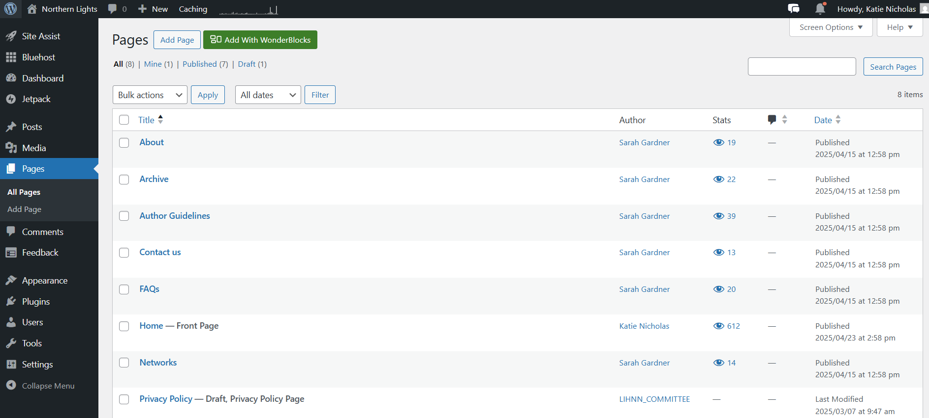

Click on the Image and click the Replace button. Upload, or select your image of choice from the library, again remembering to add Alt text.
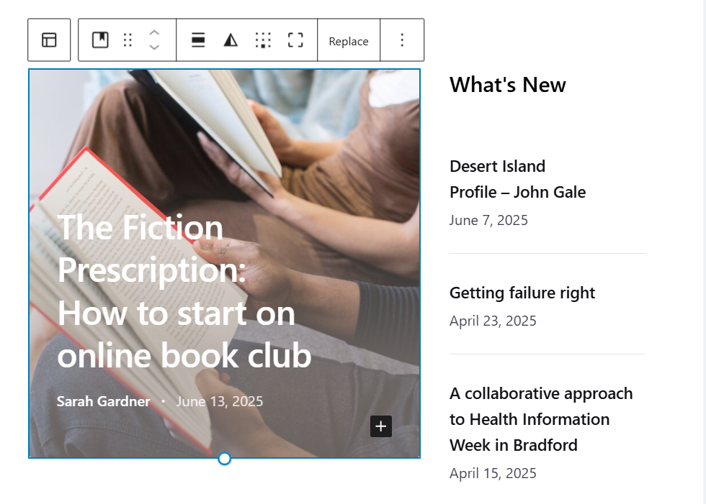

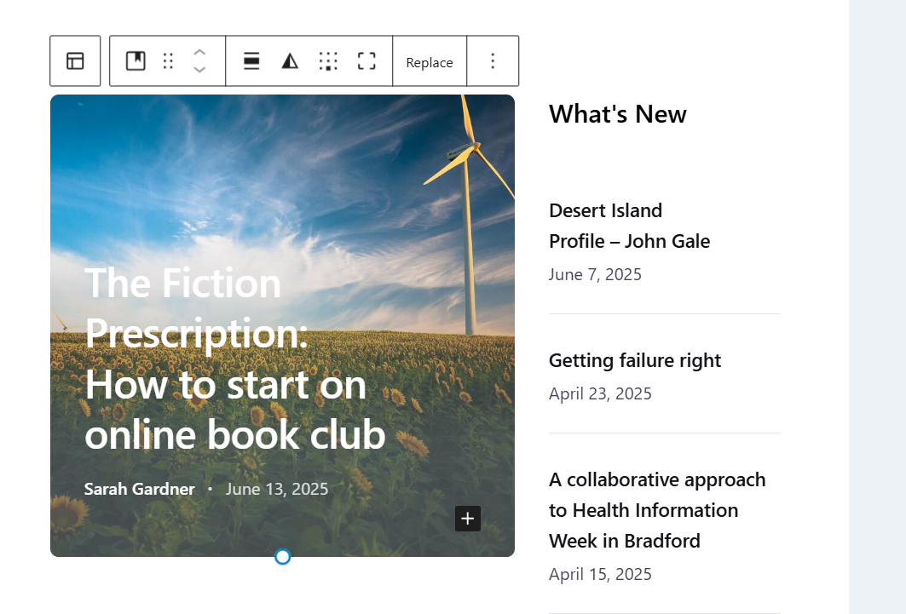

Remember to Save the page when you've changed the image. The Save button is in the top right. The post should now be live and accessible from the home page. If you want to check, visit the site and test.

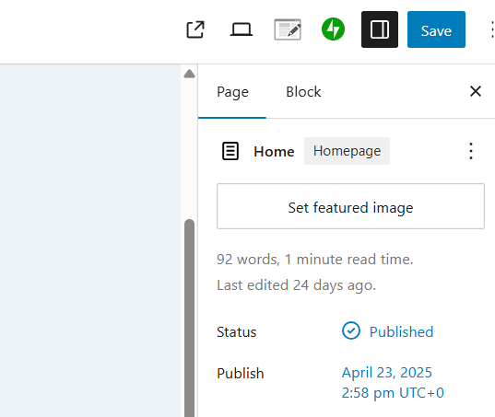

Promoting new content
Don't forget to promote the new content on the North mailing list northlks@knowledgeforhealthcare.nhs.uk
Please also copy in the Knowledge for Healthcare inbox england.kfh@nhs.net so they can include links in the national comms

It's helpful to include the individual links to each new article and information about how to submit articles (e.g. the Author guidelines page and submission email address northernlights@knowledgeforhealthcare.nhs.uk) in the emails. If you are members of local mailing lists e.g. LIHNN or YOHHLNet it might also be helpful to cascade the message there too.

You might also want to include the Northern Lights signature on your email (see below) when you send anything related to the blog out.
Firstname Lastname
Northern Lights Editorial Board
Email: northernlights@knowledgeforhealthcare.nhs.uk
Website: https://northernlightsblog.net/


